⚠️ **For number 1 i can only add coment and reaction without live edit Office (excel,word) and filter reciver**

**Add:**

Comments, reactions (have the option to turn these options on or off)

Attach files (photos, videos, and PDF, JPG, PNG, Word, Excel, and PowerPoint documents)

Have the option to add links (blue), add emoticons, add bold letters, fonts, and font sizes.

on these pages

**<https://nazarethnet.com/admin/study_material/MjgtNTUtMjE2/>**

**<https://nazarethnet.com/admin/forum/MjgtNTUtMjE2/>**

**<https://nazarethnet.com/admin/new_exam/MjgtNTUtMjE2/>**

**<https://nazarethnet.com/admin/subject_dashboard/MjgtNTUtMjE2/>**

Okay for student can see or give coments or reaction (if setting on) on this page ?  
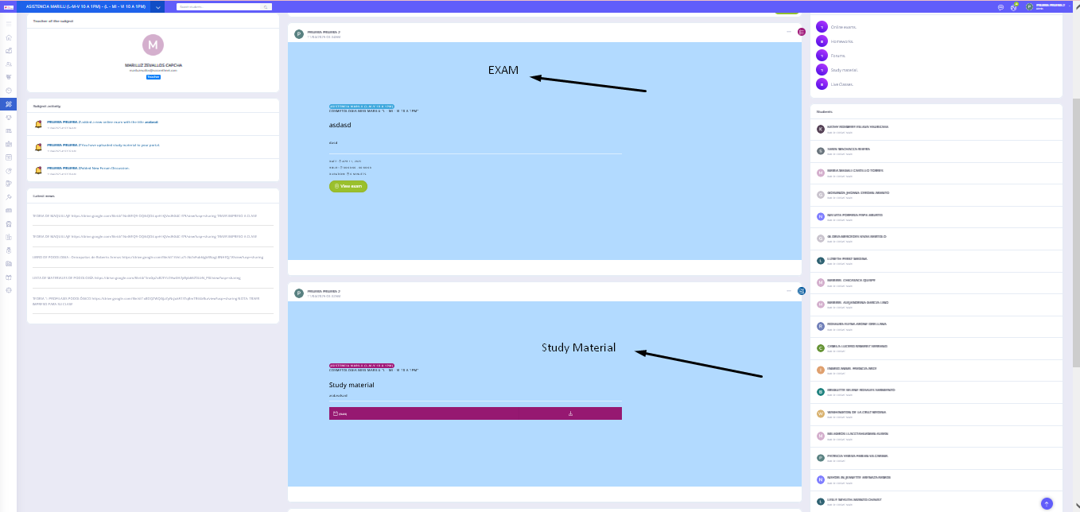

Attach files (photos, videos, and PDF, JPG, PNG, Word, Excel, and PowerPoint documents)

Where this will implemented ? i see in study material this feature is exist but not in forum and new exam, or you want implemented this in coment ? so student can coment with attach files ?

It should be implemented in the board section, online exams, homework, forum and study material.

|  |  |  |  |  |
| --- | --- | --- | --- | --- |
| board | online exams | homework | forum | study material. |
| 1. Comments, reactions (have the option to turn these options on or off) 2. Attach files (photos, videos, and PDF, JPG, PNG, Word, Excel, and PowerPoint documents) 3. Have the option to add links (blue), add emoticons, add bold letters, fonts, and font sizes. | 1. Attach files (photos, videos, and PDF, JPG, PNG, Word, Excel, and PowerPoint documents) 2. Have the option to add links (blue), add emoticons, add bold letters, fonts, and font sizes. | 1. Comments, reactions (have the option to turn these options on or off) 2. Have the option to add links (blue), add emoticons, add bold letters, fonts, and font sizes. | 1. Comments, reactions (have the option to turn these options on or off) 2. Have the option to add links (blue), add emoticons, add bold letters, fonts, and font sizes. | 1. Comments, reactions (have the option to turn these options on or off) 2. Have the option to add links (blue), add emoticons, add bold letters, fonts, and font sizes. |

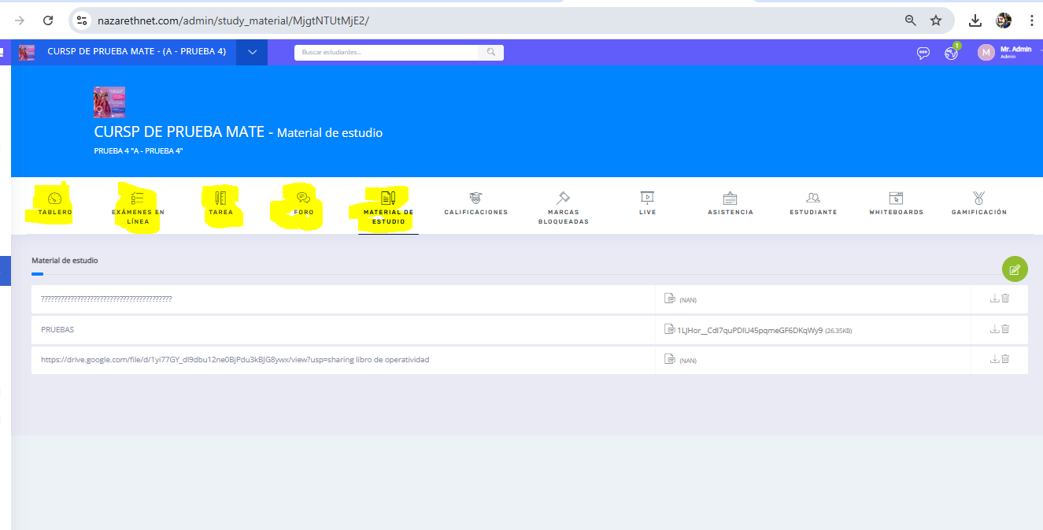

**✅ For number 2 its clear can implemented**

ok

⚠️**️ For number 3 i just can only add export student data, including attendance and student grades to excel**

You can copy an entire course and duplicate it in another section.

For example, if I am using MATHEMATICS COURSE - Section A (which includes the same grading, assignments, and exam topics), I would like to duplicate this same content for MATHEMATICS COURSE - Section B.

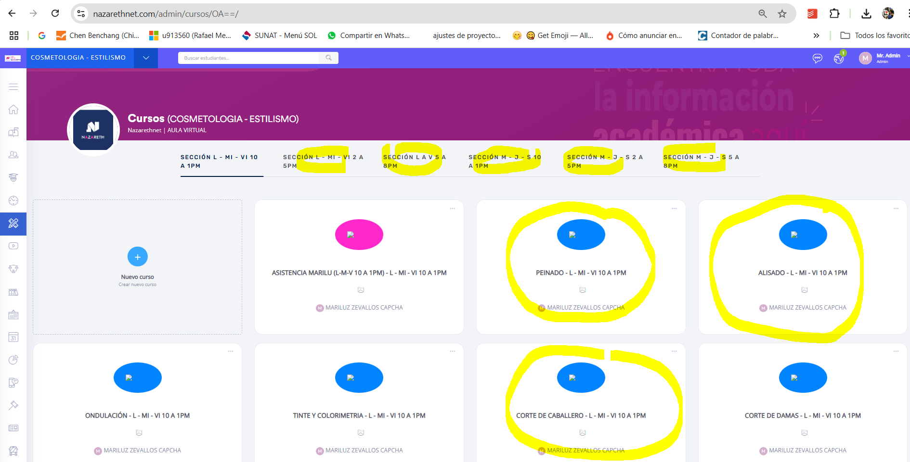

How about the student data, attendance, and grades? Will these also be duplicated when copying the course?

You could choose to copy online exams, homework, forums, study materials, and grades. Copying students, attendance, and grades is not being considered.

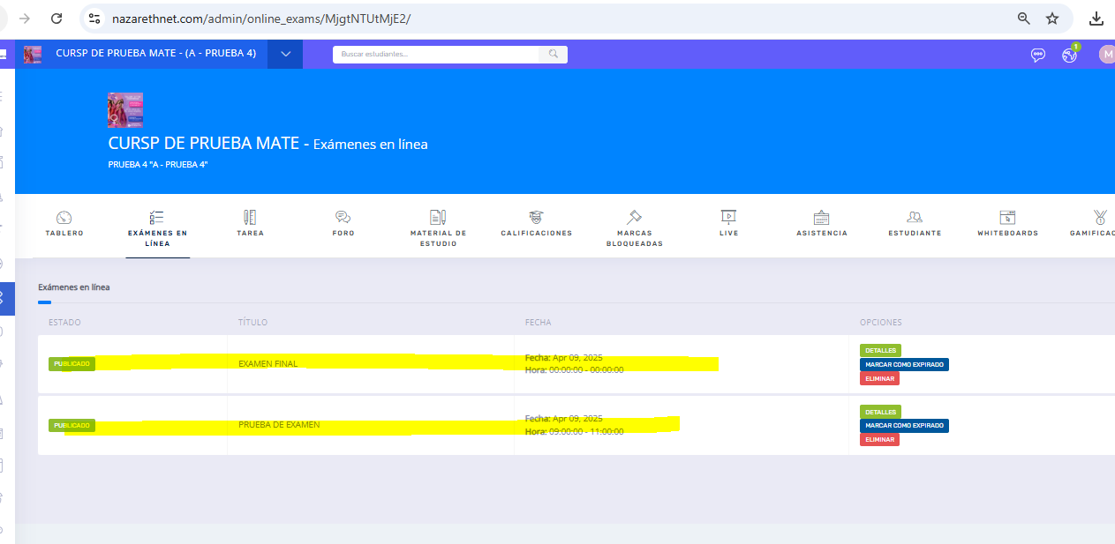

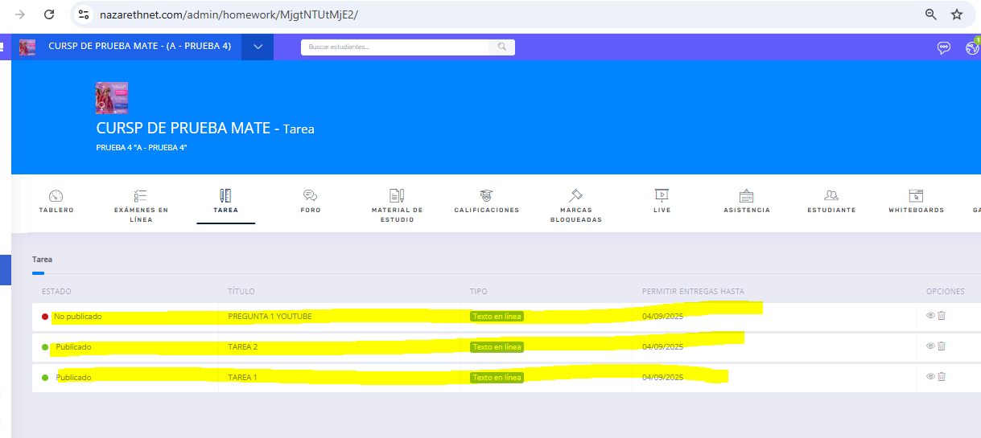

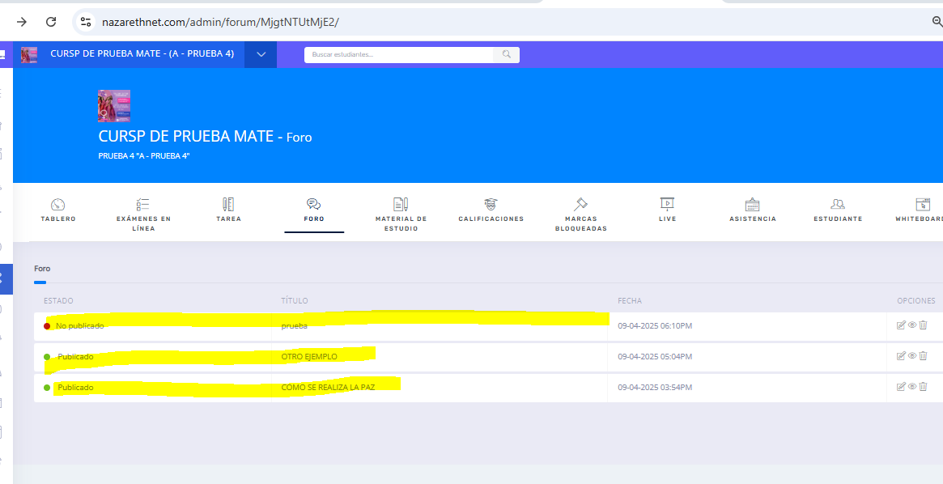

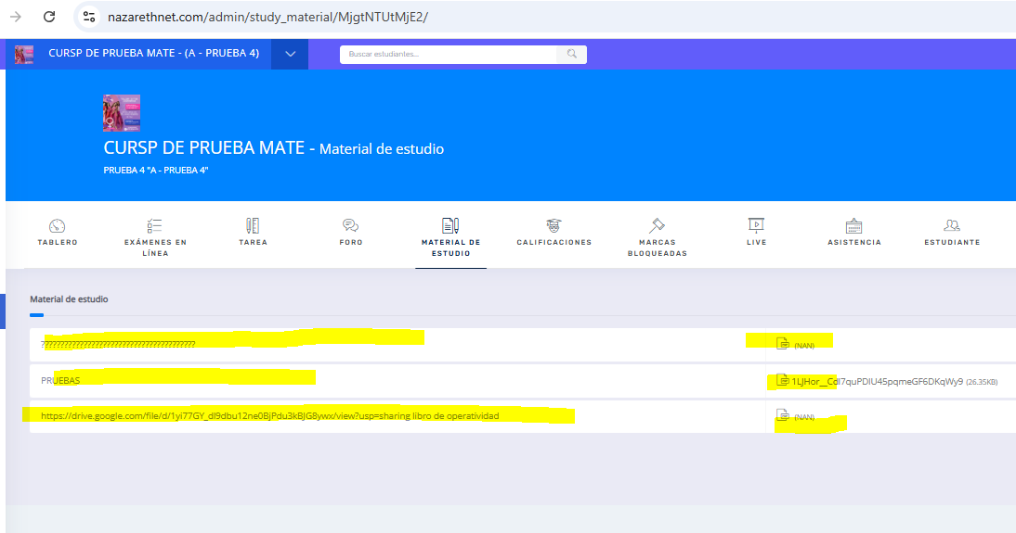

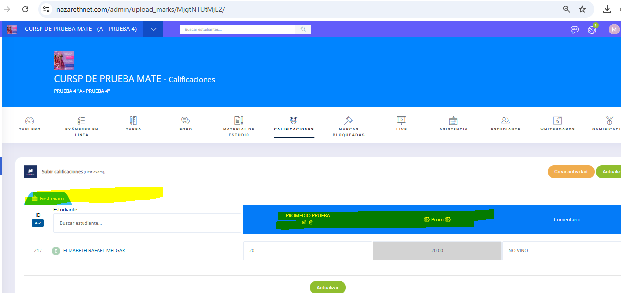

❌ For Number 4 its can't be implemented because its very complex and detail i need long time to implement this or we can place in next order with focusing in this feature

If I understand, how long would it take?

At this moment, I’m unable to provide an accurate estimate for how long this feature will take to develop. Based on the screenshot you attached, I noticed that it involves sensitive components such as student financial data and labor information. These areas require careful planning and precise implementation to avoid any potential issues or inaccuracies in the future. I’d prefer to take the necessary time to fully understand the requirements and ensure everything is handled correctly.

❌ For Number 5 its can't be implemented because its very complex and detail i need long time to implement this or we can place in next order with focusing in this feature

Implementing this properly would require significant time, planning, and focus to prevent any data loss or integrity issues. Given my current workload and the depth of attention this feature demands, I believe it’s best to allocate this task when full attention and resources can be dedicated to it.

Have the option to import the grades and attendance of the student who is changing classes or schedules.

What number is this assignment? Is it a new assignment?

This way it would also be easier for us to raise the grades of students who request a schedule change.

<https://nazarethnet.com/admin/upload_marks/MjgtNTUtMjE2/>

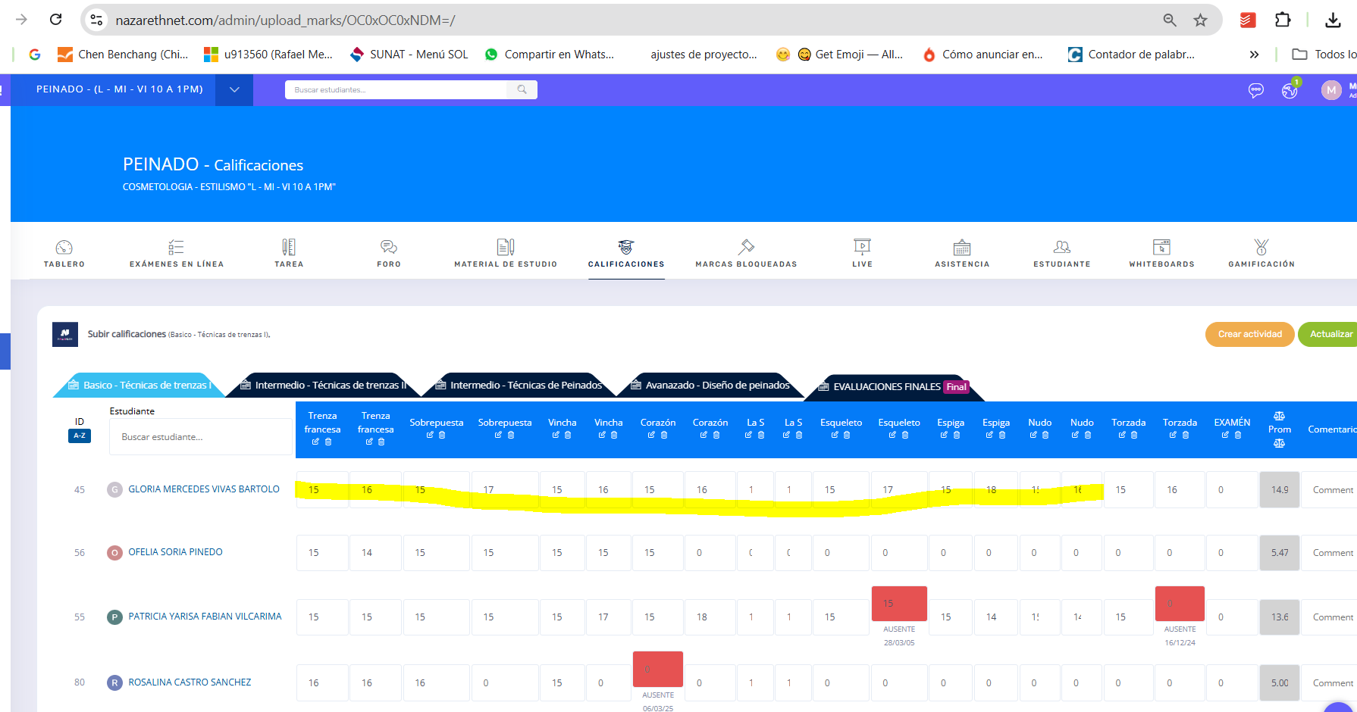

❌ For Number 6 i can implement this feature but it will useless feature because its realted to number 4 in finance student info. or we can place in next order with focusing in this feature with feature number 4

If I understand that they are related, how long would it take you to complete both points so that you can do it later?

Yes i can do it later in the next order so we will focusing on number 4 and 6?

✅For Number 7 its clear can implemented i will do with excel feature and web display

Ok

✅For Number 8 its clear can implemented

You can create a role to enable and disable certain sections, for example, you don't want the homework module to be visible in the math course, but you do want it to be visible in the science course.

Okay Noted

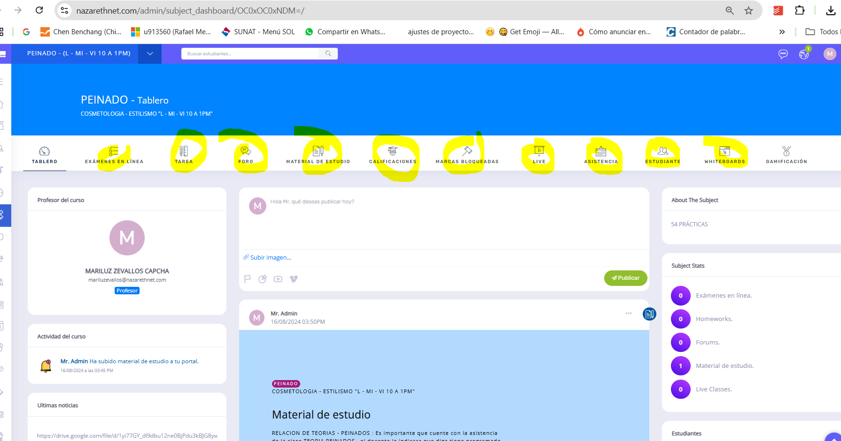

✅For Number 9 its clear can implemented and you will allowed to change certificates image

Ok

✅For Number 10 its clear can implemented

Ok

✅For Number 11 its clear can implemented

Ok